Councillors monthly bulletin – November 2022
Welcome to the November edition of my monthly bulletin, aimed at keeping Parish Councils up to date on the main news stories from East Suffolk and, where possible, giving you a heads up on issues which are emerging.

Regards,
Carol

Carol Poulter
Councillor for the Wickham Market and villages Ward
Chair: Framlingham and Wickham Market Community Partnership
East Suffolk Council

Our journey to net zero
Having declared its recognition of the climate emergency to reinforce our commitment to the environment East Suffolk Council has set a target of “net zero” gas emissions by 2030.
East Suffolk Council conducts an annual audit of emissions arising from its estates and activities. In 2021-2022 total quantified emissions stood at 5267 tonnes of CO2 equivalent (fCO2e)
Based on the Councils quantified emissions for 2021/22 the three largest contributors to our footprint are our vehicle fleet, leisure centres and housing stock. These are collectively responsible for 88.5 % of the Councils emissions. For this reason, our internal emissions reduction plans are currently focused on these key areas and an outstanding degree of success has been achieved. For examples of this success see page 5 of the latest East Suffolk Magazine which will be delivered through your door.

Ease the Squeeze
As a response to the ongoing cost of living crisis, East Suffolk Council are developing a comprehensive support programme to help residents in East Suffolk who are facing hardship Initially 12 projects will be delivered through the” Ease the Squeeze” programme which focuses on money, fuel and energy food and essentials and housing. So far, the Council committed £350,000 to the programme and are working to secure more. These projects include the warm rooms project I chair the Framlingham and Wickham Market Community Partnership and we are providing funding for warm rooms in both Framlingham and Wickham Market. I am delighted to hear that Wickham Market Parish Council is taking this further by considering providing hot food to warm room users

Wickham Market Local Plan
Congratulations to Wickham Market Parish Council for submitting its Neighbourhood Plan to East Suffolk Council ahead of it being submitted for independent examination. East Suffolk Council is publishing the plan and inviting representations which will be forwarded to the Examiner for consideration alongside the plan.
Subject to the plan successfully completing all the relevant, stages the policies and proposals will be used by East Suffolk Council in determination of the planning application within the Wickham Market Neighbourhood Area
The consultation will take place between 9th November and 21st December

New Chief Executive brings wealth of experience and shared ambition
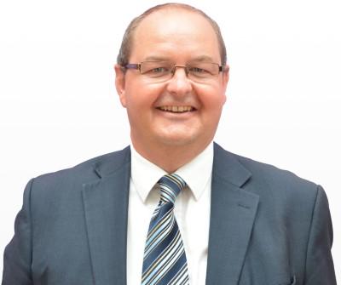 | Chris Bally has been chosen to succeed Stephen Baker as Chief Executive of East Suffok Council.  The unanimous choice of the interview panel, Chris will succeed Stephen following his retirement later this year.  Felixstowe resident Chris has worked for almost 30 years in public service.
He is currently Director for Corporate Services and Deputy Chief Executive at Suffolk County Council, where he has 13 years of experience at a senior level, following previous spells at Tendring District Council and the Audit Commission.

Chris impressed us with his knowledge, determination, and enthusiasm for the role. He entirely understands the challenges and opportunities East Suffolk faces, and it is abundantly clear that he shares our ambitions for the area.

National award for innovative Deben Fields development
A prestigious national award for high-quality and innovative design has been won by the Deben Fields development in Felixstowe.  The project, on the site of the former Deben High School, is being developed by the Council to provide new leisure and community facilities, as well as new private and affordable homes. | 
Following a submission by architects TateHindle, the scheme was shortlisted in the national Housing Design Awards earlier this year and has since been chosen as the winner of the Project Award.

The scheme comprises a highly sustainable new neighbourhood of 61 high-quality, innovative homes designed to achieve Passivhaus certification, including 41 affordable homes, and a range of community amenities.

As well as delivering energy-efficient homes, the construction process will be low carbon using durable, low maintenance materials. The homes will be highly insulated with triple glazing to lower running costs.

The buildings also maximise natural light and solar gain and are futureproofed to allow for sustainable technologies, including heat pumps and air filtration. Solar panels will provide renewable energy to power common areas.

Planning permission for Deben Fields was granted in 2021, and work is due to start in 2023.

Significant improvements in air quality at Woodbridge junction
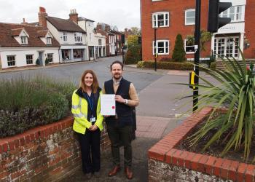 | An Air Quality Management Area (AQMA) in Woodbridge has been revoked following significant improvements in air quality.  The Woodbridge AQMA was established in 2006 after high levels of nitrogen dioxide (NO₂) were detected at the junction of Lime Kiln Quay Road, The Thoroughfare and St John’s Street.
Since this time, NO₂ concentrations within the AQMA have decreased, and since 2014, have been consistently below the national objective levels.

As a result, the Department for Environment, Food and Rural Affairs requested that the AQMA be revoked, and an assessment was carried out in 2021 to establish whether removal of the AQMA was appropriate. Using measurements taken in 2019 and 2020, the assessment predicts future NO₂ concentrations within the AQMA over the next five years and concludes that the AQMA could be revoked.

These findings were discussed by East Suffolk Council’s Cabinet on 3 May 2022, and following a six-week public consultation, the AQMA was revoked on 29 September.

Customer Services Centre to temporarily relocate
East Suffolk Council’s Customer Services Centre will be temporarily relocated to Lowestoft Library whilst refurbishment work is carried out.

Work in the reception area of the Council’s Marina Customer Service Centre was set to commence on Monday 31 October and is expected to take three weeks.

While work is carried out, the Customer Services team will relocate to Lowestoft Library on Clapham Road South, where advisors will continue to be available for face-to-face appointments, offered to customers who are unable to use online or telephone services.

The refurbishments will restyle the reception area to enable the Council’s ‘Digital Champions’ (read on for more details) to more easily help customers who need support using online services.

Opening hours will remain the same and advisors will be available at Lowestoft Library on Tuesdays and Thursdays between 10am and 4pm.

Free Wi-Fi service launched in two more East Suffolk towns
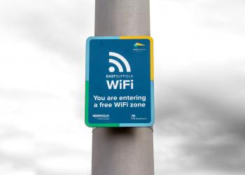 | Free-to-use public Wi-Fi has been launched in another two towns as part of a variety of digital projects for the district.  The East Suffolk Digital Towns programme has now been rolled out to Beccles and Halesworth, following previous launches in Felixstowe, Lowestoft, Southwold and Woodbridge.
The Digital Towns programme, initially piloted in Framlingham in 2019, will transform market towns through the installation of free public Wi-Fi, digital footfall counters and town marketing platforms, alongside a business support programme.

Supported by funding from the Getting Building Fund and New Anglia Local Enterprise Partnership’s Innovative Projects fund, the new technology will be combined with bespoke business support, helping local businesses and towns to grow.

It will enable us to understand the number of visitors to towns, the busiest periods, the average time people spend in the town centre and much more – enabling the Economic Development team to provide tailored support for local businesses and provide data-based evidence to support other ongoing projects.

Following the latest launches, East Suffolk Free Wi-Fi is also scheduled to be available in, Bungay, Aldeburgh, Leiston and Saxmundham very soon.

Spirit of 2012 funding to boost volunteering for local people
The Great Yarmouth and East Suffolk UK City of Culture bid team has been awarded £250,000 of funding to boost volunteering for local people.

London 2012 legacy funder, Spirit of 2012 announced the award to East Suffolk Council and Great Yarmouth Borough Council for Cultural Connections to develop volunteering in the area, delivering plans set out in its UK City of Culture bid.

Cultural Connections is a two-and-a-half-year project which aims to harness the momentum generated through the City of Culture bid to build on the volunteer offer across Great Yarmouth and East Suffolk.

The project will use arts, culture, and heritage volunteering to improve the wellbeing and life chances of its target groups, including young people, those living in deprived areas, disabled people and those experiencing social isolation.

As well as boosting volunteering in the area, Cultural Connections will help Spirit of 2012 and other funders and commissioners of events understand how the momentum of the bid process can be a platform to designing sustainable volunteer programmes, and a catalyst for social connectedness and partnership working.

Huge amounts of work went into our bid for UK City of Culture last year and although unsuccessful, that bid has provided other opportunities, such as this funding.

East Suffolk already benefits from a broad network of volunteer organisations working hard to support local people in a myriad of ways. This funding will strengthen that volunteer offer, helping to further improve the lives of all those living and working in the district.

Hat-trick of awards for building excellence in East Suffolk
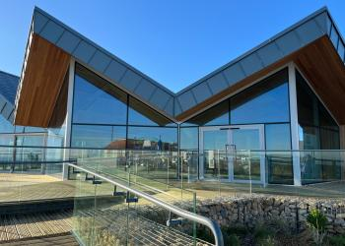 | The recently opened Martello Café, in Felixstowe, has again been nominated for a top award – along with a locally based building contractor and architect.  It was named ‘best non-residential new build’ at the regional LABC Building Excellence Awards – just a few months after being commended by local design judges.
Opened in May 2022 as part of continued wider redevelopment of Felixstowe’s South Seafront area, the Martello Café was funded with a grant of £950,000 from the Government’s Coastal Communities Fund and a further £30,000 from the Coastal Revival Fund.

Along with its architects, Plaice Design Company, the café was also ‘Highly Commended’ by judges at the RIBA Suffolk Design Awards 2022.

Felixstowe based architect, Robert Allerton was also recognised as the region’s ‘best residential and small commercial designer’ in the LABC Building Excellence Awards, while Woodbridge firm Chapel Properties won ‘best residential and small commercial builder’.

The regional winners will all go forward to the Grand Finals of the LABC Building Excellence Awards 2022 in January. They cover all local authorities in England and Wales, across 12 regions, and recognise the work of building control surveyors, builders, site managers, architects, designers, and anyone involved in a construction project where building control was provided by a local authority team.

Work begins on new Seashore Village and activity park in Felixstowe
Work has begun on the construction of a new Seashore Village and activity park in Felixstowe.  The Seashore Village will feature 27 traditional-style beach huts, provided by East Suffolk Council, as well as a single-storey accessible hut, built from self-insulating panels and capable of being split into smaller rooms or pods for hire. | 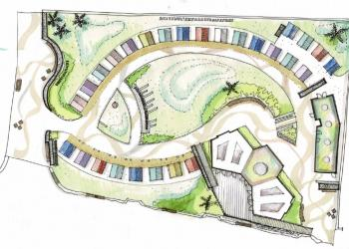
The site will be entirely re-landscaped, with ramp access installed from Sea Road and the Prom, where new fully accessible public conveniences will also be added and open year-round.
Further improvement will also be made to the surrounding South Seafront area, following the relocation and renovation of the ‘Trim Trail’, with the addition of a new activity park, set to include a climbing wall, concrete table tennis tables, pétanque piste, accessible picnic benches, chess tables and an outdoor space for workouts.The creation of the public spaces will be made possible by funding generated by the sale of the huts.The development was approved the Planning Committee South last October and forms part of wider ongoing investment in the South Seafront area. Work is being led by main contractor, Gipping Construction, and is expected to continue until next summer.
Consultation launched on major energy projects
East Suffolk Council will begin engagement with local communities following the launch of consultation on two major energy projects.
National Grid Ventures (NGV) and National Grid Electricity Transmission (NGET) have launched consultations on the EuroLink and Sea Link projects.
Sea Link is a domestic interconnector between Suffolk and Kent, required for network reinforcements, while Eurolink is an international, multi-purpose interconnector between the Netherlands and Suffolk.
Both are informal and non-statutory consultations, followed next year by formal, statutory consultations. NGV and NGET are seeking comments and feedback on their potential landfall, cable route and converter station options.
The consultations will last eight weeks until 18 December 2022. They will include some face-to-face events and webinars.
Alongside other stakeholders, we will be reviewing the material published in relation to both projects and considering our response. During the consultations, we will look to invite representatives from the affected parish and town councils to hear and understand their views on the proposals.

Diary dates

- 17th November at 6.30pm – Scrutiny Committee (Conference Room, Riverside)
- 22nd November at 2pm – Planning Committee South ((Deben Conference Room, East Suffolk House)
- 23rd November at 6.30pm – Full Council (Conference Room, Riverside)
- 24th November at 4pm – Southwold Harbour Management Committee (Stella Peskett Millennium Hall)
- 30th November at 2pm – Felixstowe Peninsula Community Partnership (The Hadwen Room, Felixstowe Library)
- 30th November at 6pm – Carlton Colville, Kessingland, Southwold and villages Community Partnership (Carlton Colville Town Council Offices)

